**IMIS LOCAL Vs IMIS ONLINE TESTING REPORT**

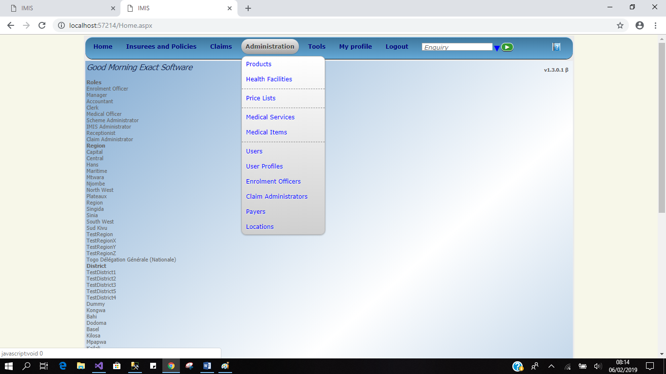

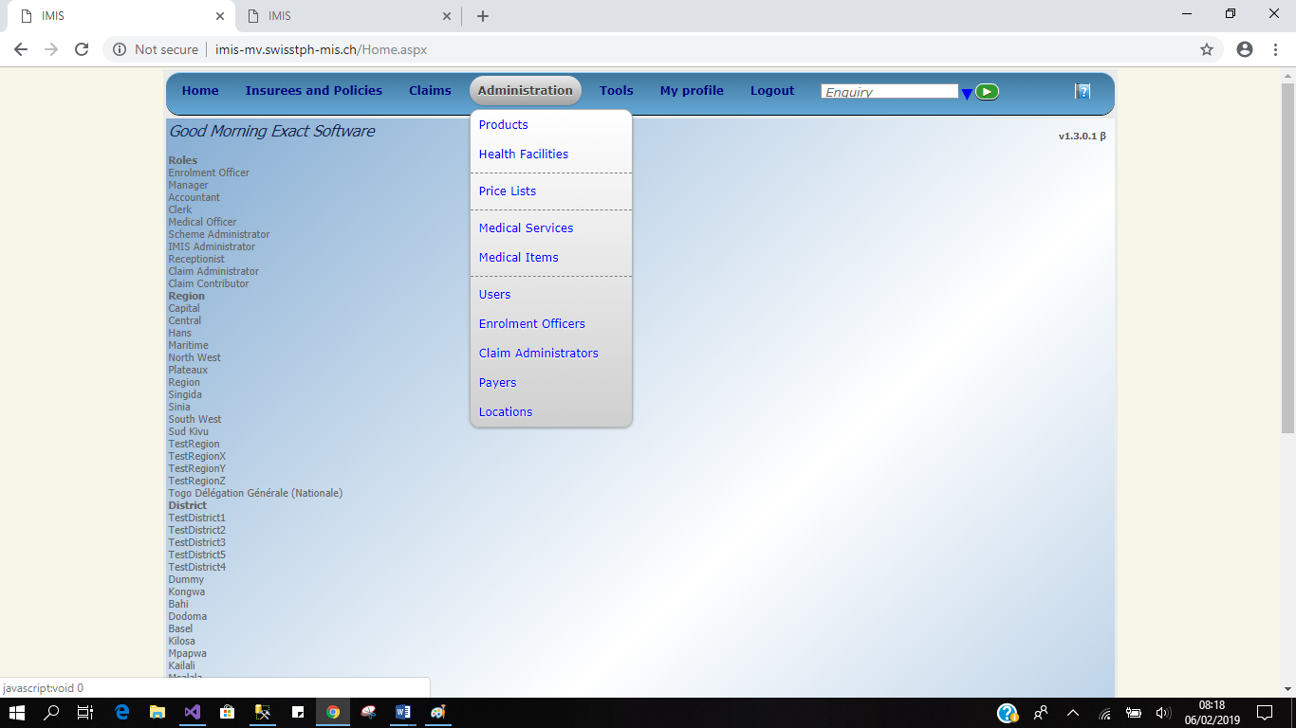

* Similarity in Rights Vs Roles
* Users page

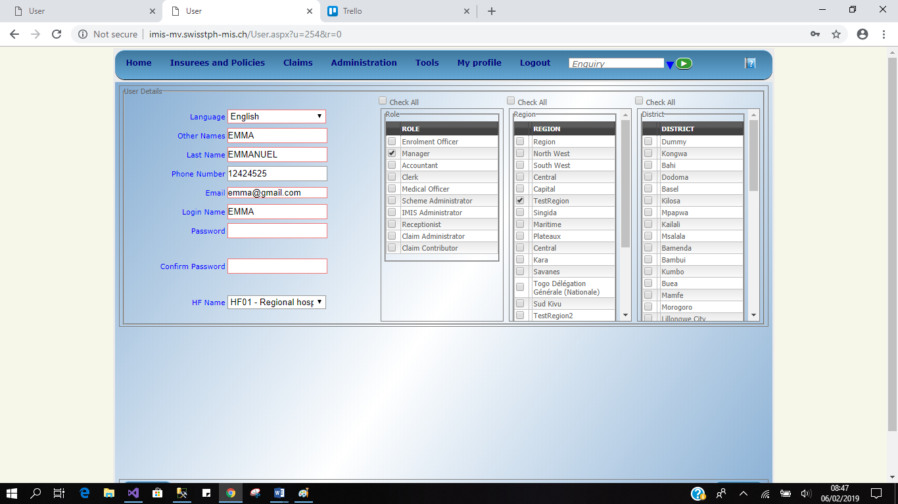

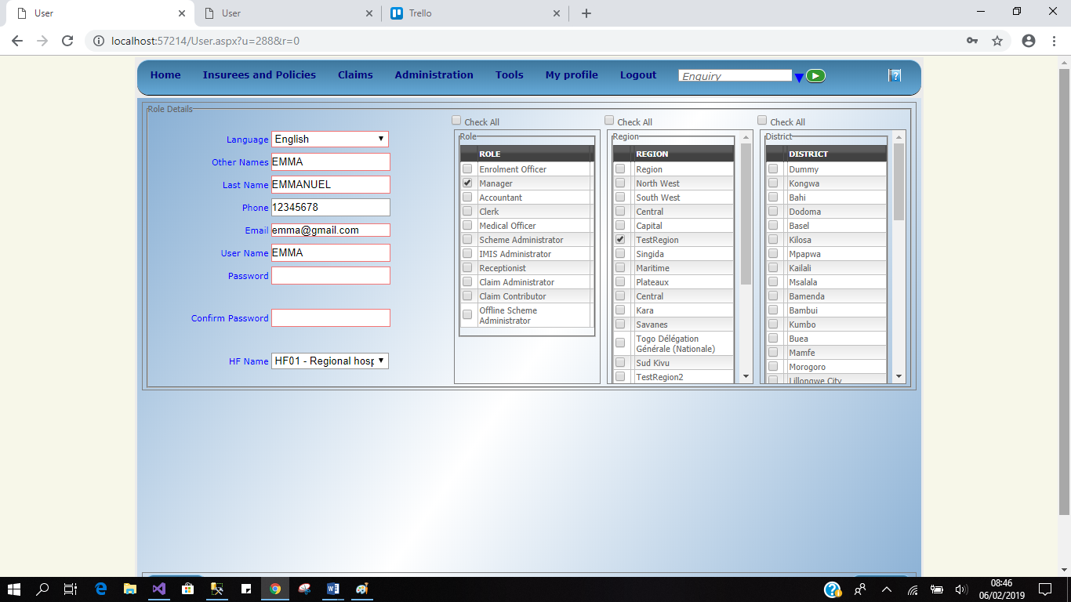

* Home page

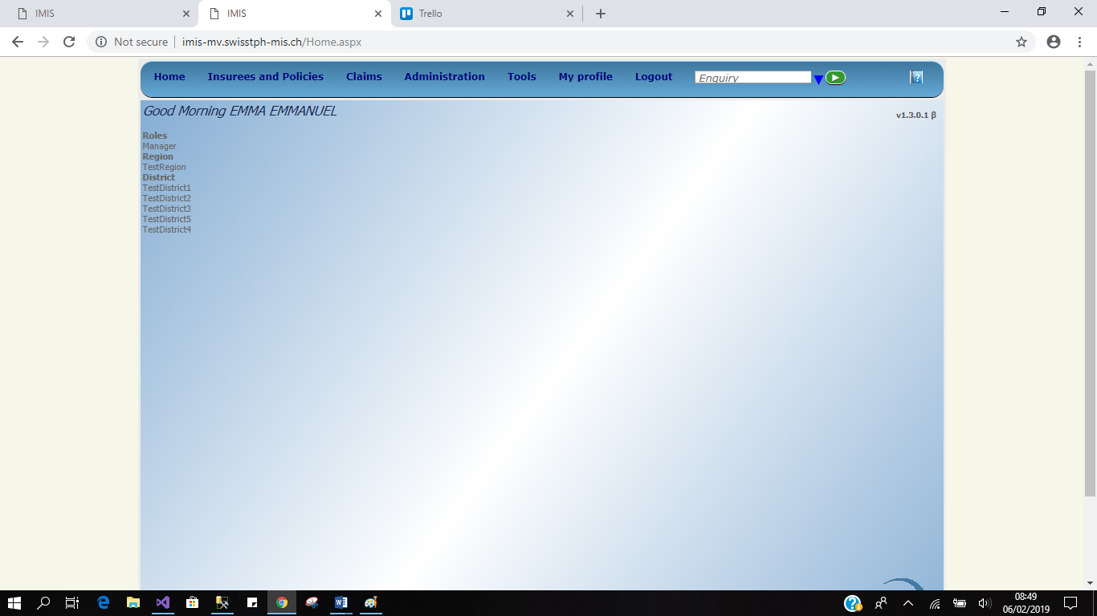

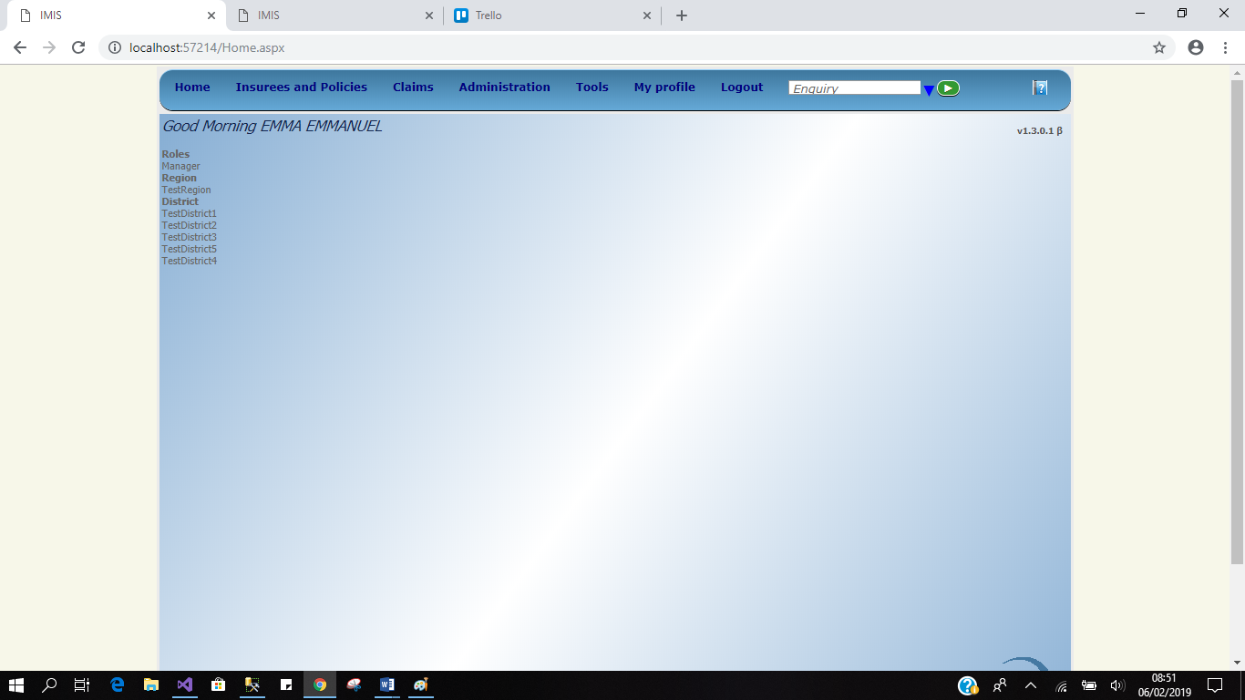

* User EMMA gets role of Manager both system local and online, blocked to access any of the menu except for Report as it shown in the images below.

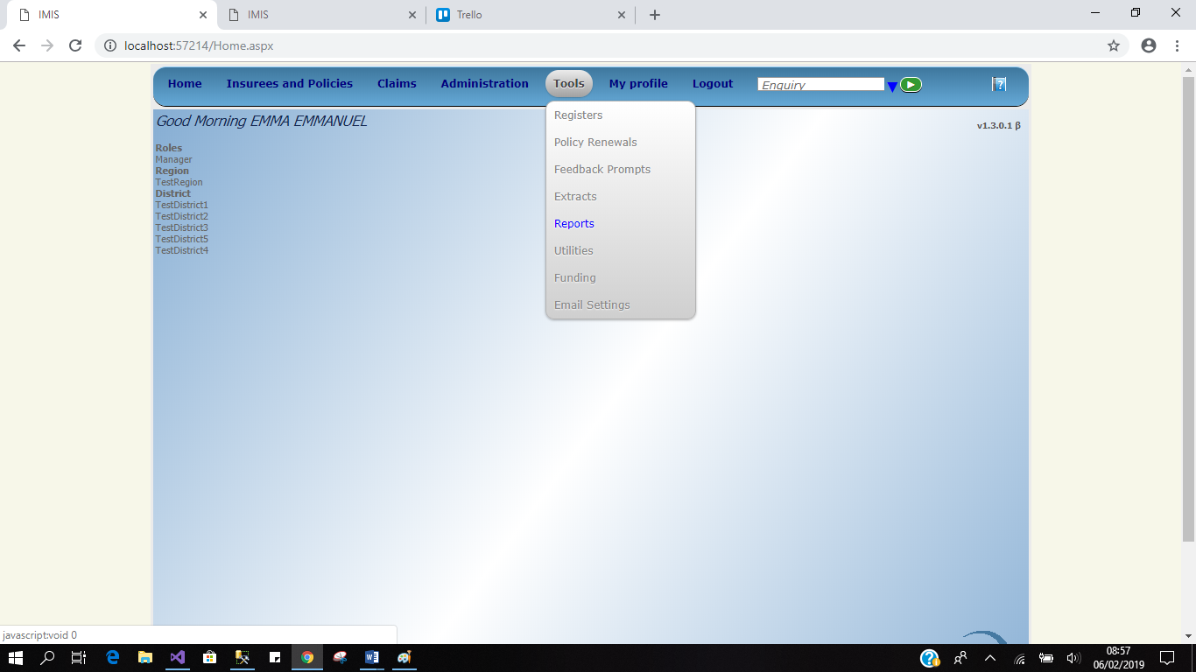

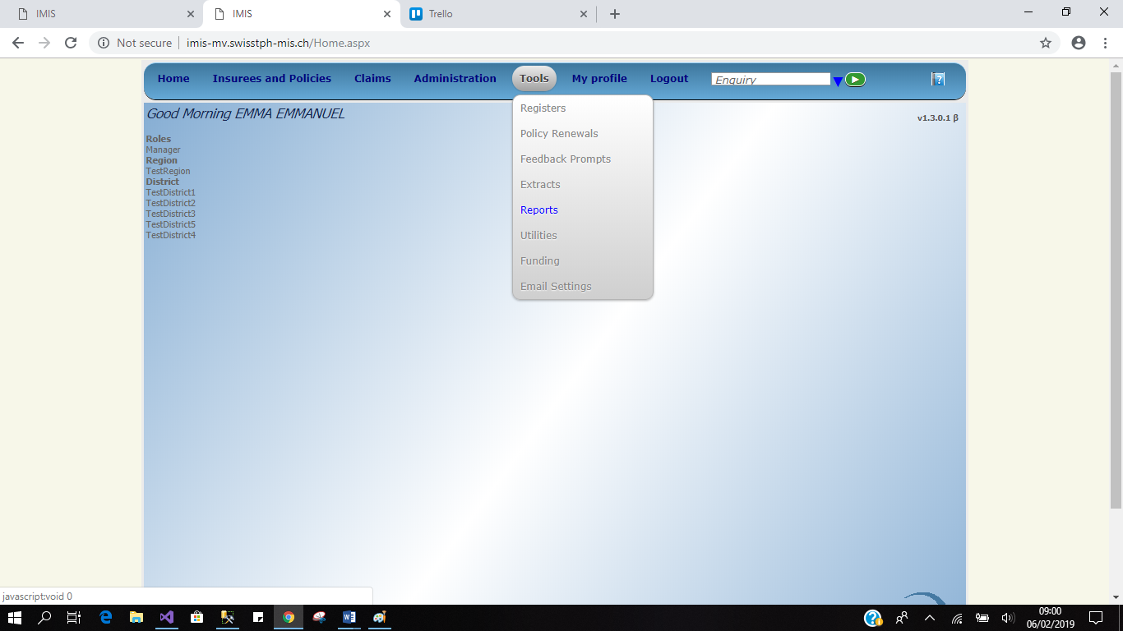

* Inside Report page

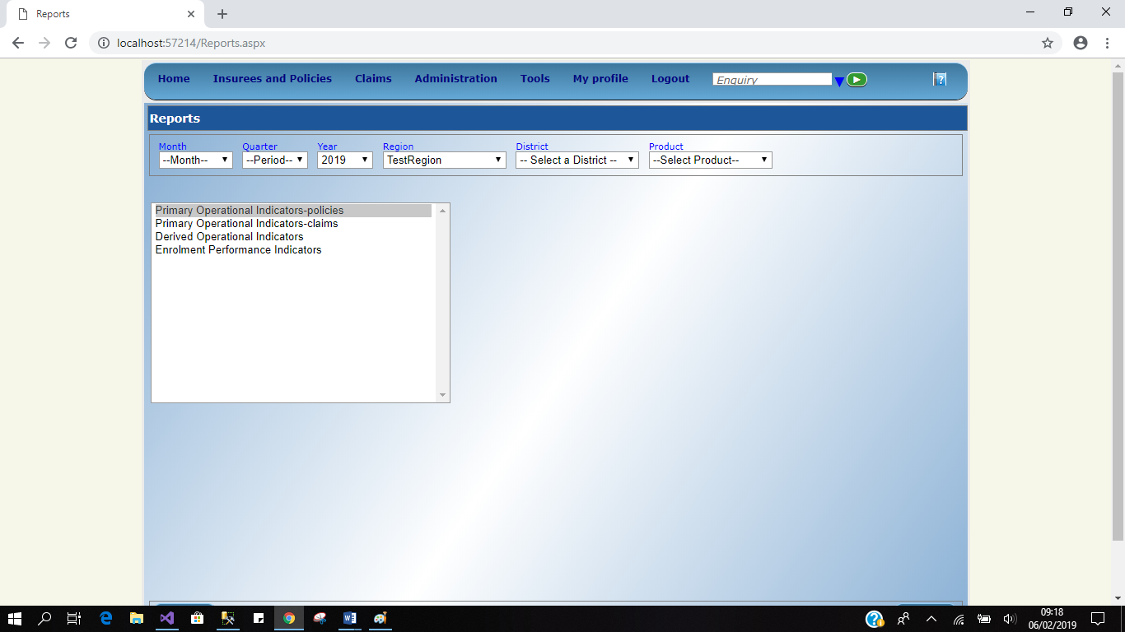

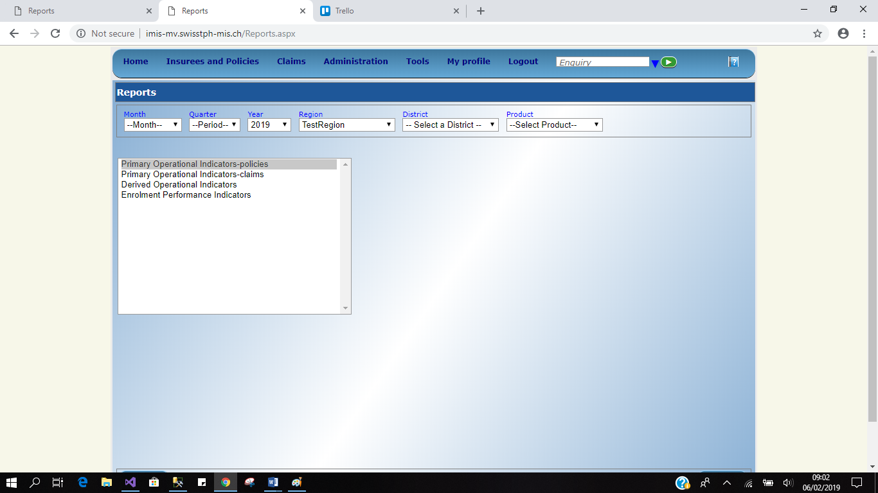

Table of comparison…

|  |  |  |
| --- | --- | --- |
| ROLE | LEGACY | NEW |
| Manager | OK | OK |
| Enrolment Officer | OK | OK |
| Accountant | OK | OK |
| Clerk | OK | OK |
| Medical Officer | OK | OK |
| Scheme Administrator | OK | OK |
| IMIS Administrator | OK | OK |
| Receptionist | OK | OK |
| Claim Administrator | OK | OK |
| Claim Contributor | OK | OK |
| Offline Scheme Administrator | Found in Local System only | - |
|  | Tested all roles to one user |  |